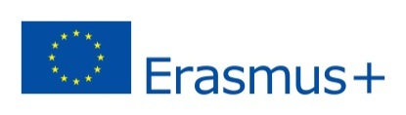
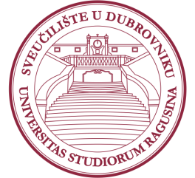
University of Dubrovnik
6th Erasmus+ Staff Week
March 30 – April 3, 2020

Application Form for Teaching Mobility

Name/Surname:
Title/Position:
E-Mail:
Institution/ City/ Country:
Faculty/Department at home institution:
Scientific Field (e.g. Mathematics, Economics, Engineering etc.):
Name the courses you teach at your home institution:
Comments/special requirements (any special IT equipment should be stated here):

We kindly ask you to send the filled Application form until February 14, 2020 to international@unidu.hr.

Please note that the places are limited and there is a possibility that we will not be able to accept all applications, especially in case of several applicants from the same scientific field. We will inform you about the approval of your application by February 21, 2020 at latest. After the acceptance confirmations are sent, more details about the final Staff Week Program will be provided to participants. Please note that transport and accommodation is a personal responsibility of the selected candidates.
In case of any further questions, please do not hesitate to contact:
Mrs. Sandra Memunić (Head of IRO): sandra.memunic@unidu.hr; +385 20446041
Ms. Nina Mijoč (International Relations Officer): nina.mijoc@unidu.hr; +385 20446061

We look forward to welcoming you at the University of Dubrovnik!

